APTEK® 2210-A/B Mixing Instructions
for Pre-Measured Kit

- Open Mil spec bag and verify contents:
1 Part-A plastic container
1 Part-B 3cc syringe with hand plunger
1 Metal spatula
1 Green dispensing tip
2 Desiccant Bags

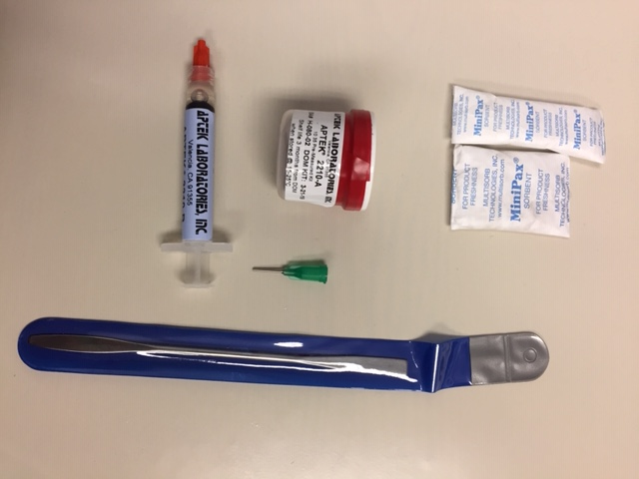

- Remove cap from Part-A container and set open container on flat surface.

- Hold Part-B syringe so orange end-cap is pointing upwards. Remove orange end-cap and replace with green dispensing tip.

- Push hand plunger until it mechanically stops to dispense contents of Part-B syringe into Part-A container. NOTE: If a drop of Part-B remains in dispensing tip, carefully wipe the drop onto the inside of the Part-A container.

- Using the metal spatula (use rounded end so as to not scratch A-side container), mix thoroughly until fully homogenized, making sure to scrape material off spatula and homogenize. Resultant mixture should be a uniform, smooth paste. If clumps of material or veins of fluid are noticed, continue mixing until uniform.

- Material is ready for application use.

