How To Use Injector Kit By Hand

- Check contents of Injector Kit package:
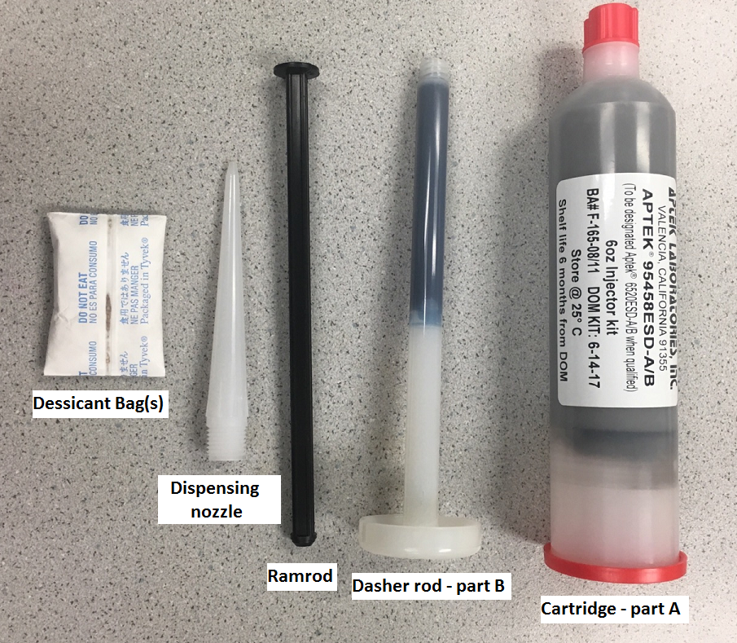
- Unscrew the red cap from the tip-end of the cartridge containing the part A.
- Hold the dasher rod, containing the liquid part B, by the circular base and insert the threaded end of the dasher rod into the tip-end of the cartridge. Rotate the dasher rod clockwise until the tip of the dasher rod has been engaged and securely threaded into the mixing propeller within the cartridge. You will see the mixing propeller start to rotate with the dasher rod once the dasher rod is engaged.
- Push the dasher rod/mixing propeller all the way up against the clear plunger at the back of the cartridge. Leave the red end-cap on the back of the cartridge.
- Pull back the dasher rod/propeller ~1/4 the distance of the filled portion of the cartridge.
- Insert the black ramrod into the opening in the circular base of the dasher rod.
- With firm but even pressure, push the ramrod into the dasher rod until the valve-seal just pops open. Do NOT force ramrod all the way in at this time.
- Carefully inject ~1/3 of the part B contents into this area within the cartridge.
- Pull back the dasher rod to the middle of the filled cartridge and using pressure on the ramrod, inject another 1/3 of the part B contents into the middle area of the cartridge.
- Pull back the dasher rod all the way to the tip-end of the cartridge and inject the remaining contents of the part B liquid. *Note: this method of partial part B injection is important to evenly distribute the catalyst into the part A prior to mixing.
- Remove the ramrod from the dasher rod.
- To mix, hold the cartridge with one hand and hold the base of the dasher rod with the other hand and begin stroking the dasher rod in a spiral, clockwise motion, by pushing the dasher rod to the end of the cartridge, and then pulling back to the tip of the cartridge. Rotate the dasher rod 90⁰ to the right with every stroke. One stroke equals the pushing up and pulling back motions. The product label will direct the user on how many strokes are required to fully mix the material. After mixing, visually inspect the cartridge to ensure that there are no obvious areas of unmixed material.
- Once fully mixed, push the dasher rod to the end of the cartridge and firmly hold the cartridge at the end to secure the propeller in place. With the other hand, unscrew the dasher rod counterclockwise to disengage the dasher rod from the mixing propeller. Carefully remove the dasher rod.
- Attach the dispensing nozzle to the threaded cartridge end and remove the red end cap from the cartridge. The material is now mixed and the cartridge is now ready to be placed into a pressurized apparatus for dispensing.

